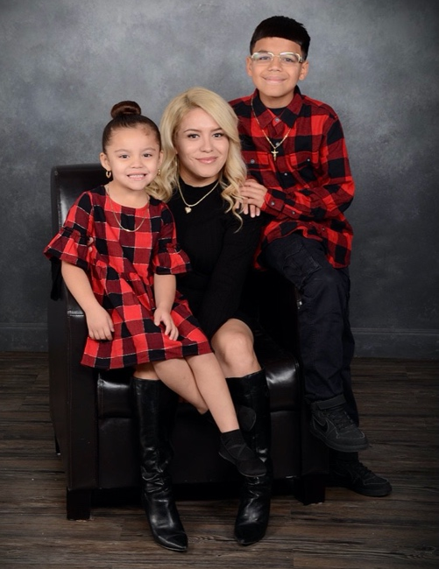
Tracey is a single mother working hard every day to make a better life for her two children, Jesse (12) and Jazlynn (6). They are a fun-loving family who enjoys spending time together, having family movie nights and being outdoors around Lady Bird Lake. She cares about the Austin community and currently works as an assistant property manager for Foundation Communities, a nonprofit that provides housing and resources to those in need. She has lived in Austin her entire life and has watched the city transform and grow. With this growth, she has been priced out of decent housing that can safely accommodate her family. She now lives in an apartment in a part of town where she does not feel safe. They live on the fifth floor of a building with a frequently out of order elevator and she does not allow her children to play outside because of the crime rates in their area.
When Tracey first approached Austin Habitat in 2018, she did not qualify for our program. However, she worked tirelessly using the tools provided from our housing counseling sessions to improve her credit and become a candidate for a home. Now she will be the first person in her family to own a home and fulfill a lifelong dream of having something that is truly hers in this city that she has loved since birth. An Austin Habitat home will provide her with a safe place to raise her children, where she does not need to be concerned about them walking home from the bus stop or playing with neighbors down the street. That sense of security will allow her to focus on her personal goals; saving for her children's future and advancing in her career.
Tracey loves the Habitat model, and she feels blessed for the opportunity to be able to help build someone else’s dream, while they in return help her build hers. She is proud of herself for how hard she has worked to get to this point and cannot wait to open her own front door and step into her future with her family. She wants all the Community Build sponsors, donors, and volunteers to know that their work is appreciated. Every donation, hammer swung, or nail put in place is a small step towards the end goal and means a huge amount to someone like her and her family. She is beyond grateful for this opportunity.

